ACIT 3640 – Part 3
AWS Billing Alarm

- Log into your AWS root account.
- In the top right corner, click on the drop down menu next to your name.
- Select “My Billing Dashboard.”
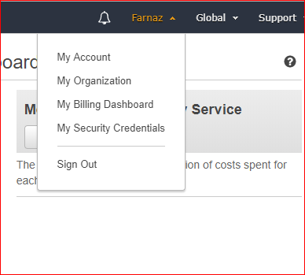
- On the left side of the screen, click on “Billing preferences".
- Under Preferences, click “Receive PDF Invoice by Email” and “Receive Billing Alerts.”
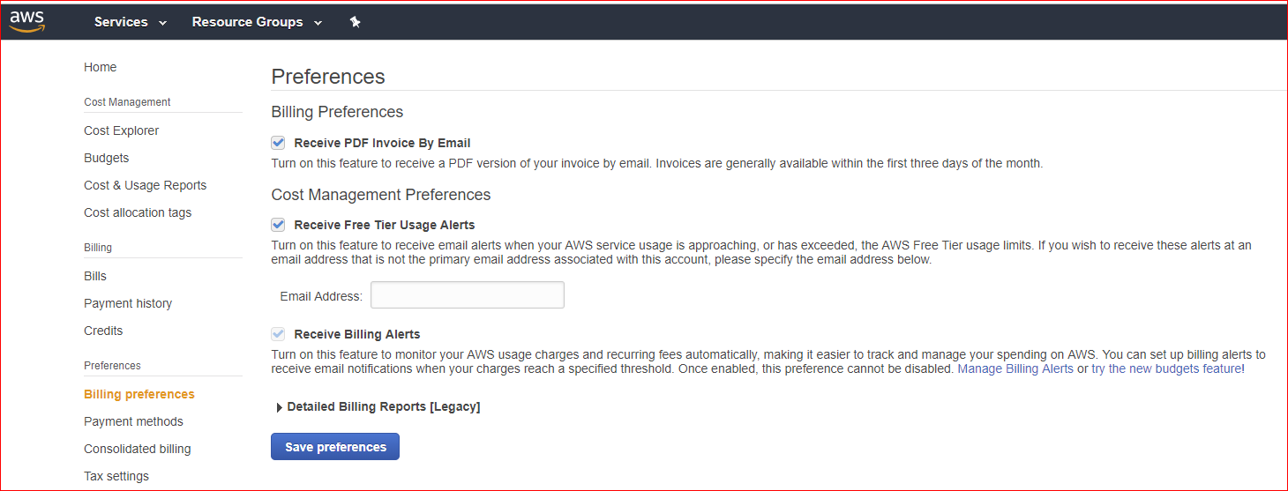
- Save the Preferences.
- Click “Manage Billing Alerts” under the “Receive Billing Alerts” paragraph.
- This will take you to the CloudWatch area of the AWS Console. We will go into more detail on this in later labs.
- If necessary, change the Region to US East (N. Virginia). Billing metric data is stored in this Region and represents worldwide charges.
- On the left side, click Alarms.
- Click “Create Alarm.”
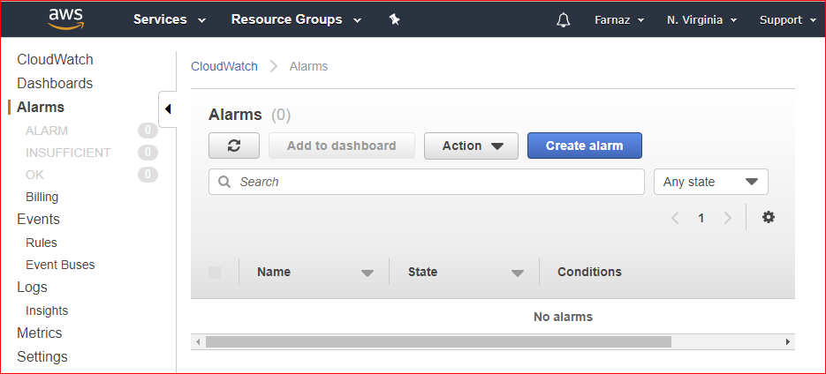
- Choose “Select metric”. In the All metrics tab, choose “Billing”, “Total Estimated Charge”.
- Select the check box next to EstimatedCharges, and choose Select metric.
- We want to receive an email when we receive ANY charges. Under Whenever Estimated Charges is, select Greater and enter the monetary amount (“0.01” USD) that must be exceeded to trigger the alarm and send an email.
- Click on next.
- Enter your email address and set the name as Billing Alarm.
- Click on create alarm.

